**Classroom Activity​: Write a function to generate first n prime number​ in js code**

**Code-**

const n = 10; // You can change this value to generate a different number of primes

const primes = [];

let number = 2; // Start checking for prime numbers from 2

while (primes.length < n) {

let isPrime = true;

if (number <= 1) {

isPrime = false; // Numbers less than or equal to 1 are not prime

} else if (number <= 3) {

isPrime = true; // 2 and 3 are prime numbers

} else if (number % 2 === 0 || number % 3 === 0) {

isPrime = false;

} else {

for (let i = 5; i * i <= number; i += 6) {

if (number % i === 0 || number % (i + 2) === 0) {

isPrime = false;

break;

}

}

}

if (isPrime) {

primes.push(number);

}

number++;

}

console.log("First " + n + " prime numbers: " + primes);

**Output-**

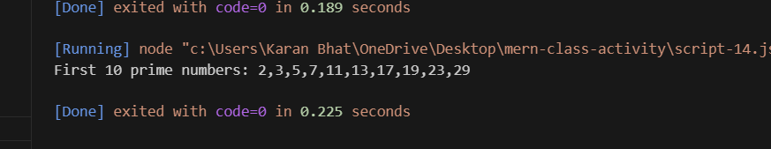

**Execution-Steps:**

* Create a JavaScript file with any name
* Write the code
* Run the code in the terminal using F5 or right click and go to inspect and you can get the output in the console as well.